**10 COMMITMENTS TO DEFEND AND EXPAND**

**THE RIGHTS OF THE LGBTI+ COMMUNITY**

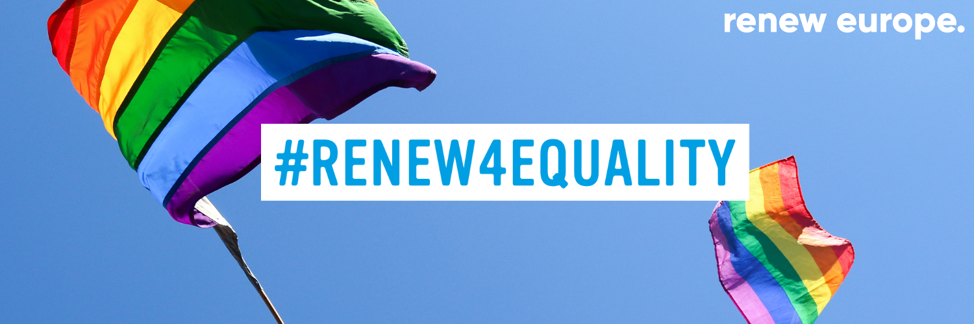

**3 MARCH 2020**

**AGENDA**

9:00 - **Welcome** Coffee

9:00 - Welcome & Opening by **Dacian Cioloș**, President of Renew Europe

9:10 - **Presentation** of the Renew4Equality 10 commitments for LGBTI rights by MEPs

* **Sophie In't Veld**
* **Irène Tolleret**
* **Moritz Körner**
* **Maïté Pagazauntundúa**
* **Nicolae Stefanuta**
* **Frederik Federley**
* **Anna Donath**
* **Radka Maxová**
* **Liesje Schreinemacher**

09:25 - **Keynote** speech - **Helena Dalli**, Commissioner to Equality

09:40 - **Reactions** from our guests

* **Evelyn Paradis**, Executive Director, ILGA Europe
* **Clare Hart**, Vice Chair, Association Le Refuge
* **Ralf Fröhlich**, President, LGBTI Liberals of Europe
* **Pawel Rabiej**, Vice-President, Capital City of Warsaw (TBC)

10:00 - **Debate**

10:25 - **Conclusion** by Renew Europe MEPs **Sophie In’t Veld** and **Irène Tolleret**